Arab American University
Administrative and Financial Sciences
Operations Management Department

“Automating a clinic system”

Prepared by:
Jacob Qaisi | ID #: 21512093
Qais Sadaqa | ID #: 21510238
Hamzi Zaid | ID #: 21510805

Presented to:
Dr. Azmi Essa

Course Name:
“System Analysis and Design”

Semester 2018/2019
AL-HAYAT RADIOLOGY CENTER

General
Al-Hayat Radiology Center is a medical that treats a high volume of patient daily. The job is growing rapidly and the center needs to hire new doctors and managers to handle the volume of patients.

The center now is facing a new problem because of the growth of practices. The managers and doctors are doing their job manually, they don’t use computers or any software to do their job such as: “new patients, new doctors or even old patients who are treating with this center”, which means that everything is stored on papers and files. And this thing leads to a big problem with treating the increasing volume of patients.

this can cause a big problem for the center like:

- Difficulty in keeping files of all patients and may be damaged during preservation.

- It may cost the manual process to register and blogging large amounts of papers and places to save.

Description the current system before development:

- Patient registration:
When the clinic comes, a file is given to record the necessary data and analysis so that it can be ID at the clinic when booking and installing an appointment.
- Updating the patients data:
When the patient wants to update the data he/she needs to contact the clinic and extract his/her file and re-fill his new data.
- Making an appointment:
When the patient wants to book an appointment that needs to be connected to the clinic and through the clinic, their schedule is considered and booked in a timely manner for the doctor.
- Changing an appointment:
When the patient comes or contacts the clinic, the secretary changes his name, his number and the current appointment and records it on the date he wants if it is available.
- Deleting an appointment:
When the patient arrives or calls to cancel the appointment the secretary takes his ID and his number and the current date and looks for the file in which the patient's data and cancel it.

Problems with the current system :
- The file of patient needs a large of storage place.
- If the patient loses his or her file number or data, it is difficult to search and is searched manually.
- If the patient wants to contact the clinic and know his / her current date, he / she will be searched manually.
- Searching for specific patient information takes a long time.

The new system objectives:
- Increasing business opportunity.
- Connecting medical record and Exchanging medical data with Government regulation standard.
- To improve patient safety by:
- Ensure that leaders establish and sustain a safety culture.
- Prioritize employee health.
- Ongoing education is crucial.
- To support effective and efficient health care delivery by:
- By providing the appropriate environment for treatment.
- Providing trainees with distinguished doctors who work actively.
- Providing advanced equipment for testing.

The phases of the project:

- Identifying the problem:
Doing a meeting with managers and employees is to identify the problems we face and how through the new system these problems will be resolved A clinic wants to develop itself through two projects:
The first one: (Connect the doctor with the secretary)

The project clinic management is a software developed to simplify the communication
Process between the doctor and the receptionist. The software would be operated by two admins one is doctor and the other is receptionist. Receptionist would be responsible for assigning token numbers to the patient visiting the clinic and save it in the database along with their details. These token numbers along with respective patient details are sent to doctor. The doctor can thus view patient details and after checking up the patient, the recommended medicines for the particular patient are fed into the database by the doctor and are sent to receptionist. The receptionist can then generate bill and feed into the database. The system also maintains patient’s history so that doctor or receptionist can view them anytime.

Second: (Connect a radiologist with other clinics)
This project works during the use of patient information when the patient comes to the clinic to give him a questionnaire and through this questionnaire is answered some questions, such as with any doctor deals with any other clinics and through this are included in these clinics in order to facilitate the treatment of the doctor with doctors Other Clinics.

2. Feasibility study:
We use feasibility study to identify the problems we face and to identify the tools that we will use and determine the cost through:
- Gather information about the problems and the problems you will face.
- Make a cost estimate for the new system tools.
- Conduct a thorough assessment of the processes to determine which phase to follow.
- Show the management how the process flow and decide to continue or not.

3.analysis:
to determine the requirements of a proposed new system which involves:
- Study the current and analytical system.
- Preparing a list of new system requirements.
- Diagramming the functions of the new system.
- Preparing prototype of the system.
4.desgin:
Once a design team has been agreed upon and assembled, the owner needs to coordinate and manage the project's design phases. Design management requires the oversight of schedules and budgets; review of key submissions and deliverables for compliance with program goals and design objectives; verification of stakeholder input for inclusion; verification of construction phase functional testing requirements; and appropriate application of the owner's design standards and criteria. This stage should also define the criteria for assessing quality measurement to ensure the project's success.

5.construction:
- Installation of tools and preparing them.
- Writing the new system and experimenting and correcting problems.
- user should try it and meet their demands.
- Document the information on the old system and train who will use the new system to use it.

6.conversion: (form old system to new system)
- Installing the new software
- Entering the new data need and old data to new system.
- Staff start using the new system
7. Maintenance:
The system must be monitored, and its problems identified and each period of development work on a system to keep pace with development.
- Slipstream Upgrade
Minor upgrade not worth announcing.
- Patch
Minor change to correct a problem or make a small enhancement.
- Release
Significant program change that often requires changes in the documentation.
- Version
A major program change, typically encompassing many new features.

Alternative solutions
- Note: These are other solutions to the problems we face now
- Recruit other staff to handle files and arrange them.
But these solutions have disadvantages like:
- The employer may cost more expenses
- Extra space for new employee
- any change in clinic need to fit the new staff
2. Organize and document the work of the clinic on a computer, which saves them the use of a lot of paper and files.
Also, these solutions have disadvantages such as:
- When a hardware malfunction affects the work of the clinic, some information may be lost
How the new system work through
- Patient registration:
When the patient comes to the clinic, he is given a questionnaire to record his registration and when it is registered, it is entered into the new system. Each patient has a special number and enters it as a primary key to search for it easily.
2. Updating the patient’s data:
When the patient wants to make changes to his file, the new information and the file number are taken, and the file is entered only if the number is correct When the file is found, modifications are made.
3. Finding a patients file:
What to do the secretary to find a patient file is to enter his own number and the system automatically searches for it and shows it.
4. Changing an appointment:
When the patient wants to change his appointment, call the clinic and tell them Then the secretary take his name and number and take the current date and to the date he wants to change after the secretary to ask for his file and make a change and compare it with the schedule of the clinic and certainly the date on the appropriate date as he wants with the dates of the clinic.
5. Deleting an appointment:
Sometimes the patient wants to cancel the appointment and call the clinic and tell them then take the secretary number and his name and date that wants to cancel and then search for the patient file in the system and cancel the appointment.
6.Extracting the daily appointment schedule of the clinic:
Every day, the secretary will extract dates for the day, any times, the first appointment at any time, and the last date at any time. The name of the patient and the types of medical tests to be performed

Construction of new system
- Installation of tools and preparing them.
2. Writing the new system and experimenting and correcting problems.
3. The user should try it and meet their demands.
4. Document the information on the old system and train who will use the new system to use it.

Hardware and software needed for new system
Hardware, such as:
- MB 854E Intel
- Inter® Core™ i5-5200U CPU@ 2.00GHz
- Windows 7 or earlier
- 1024 MB DDR
- CD RW 12x2x24
- sound card 7 channel
- fax modem
- flat monitor
- wireless keyboard
- printer
Software, such as:
- Internet Explorer 5.5 above
- Java web starter 6.0 above
- MySQL 10.0.1 above
- Tomcat web server 6.0 above
- Hardware requirements
Context Diagram

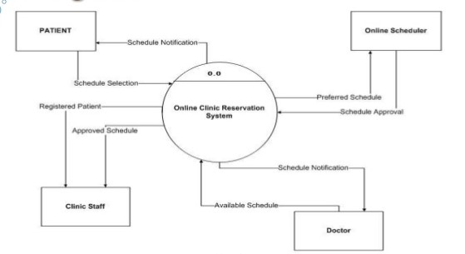

Activity Diagram For
Get Patient Information
Check Patient Details
Create new patient
Get Appointment Request Details
Change Appointment
Cancel Appointment
Create New Appointment
Check Appointment Slot
Schedule Appointment
Get Appointment Details
Update Patient Details
X
Take Alternative Datetime
X
Make Payment
Obtain Treatment
X
[New Patient]
[Slot Found]
[To Cancel]
[New Appointment]
[To Change]
[Old Patient]
[Not Found]
[Patient Arrive]
[Patient Absent]
[Provided]
[Not Provided]
[New Patient]
[Old Patient]
Al-Hayat Radiology Center

Data flow-AL–Hayat centre
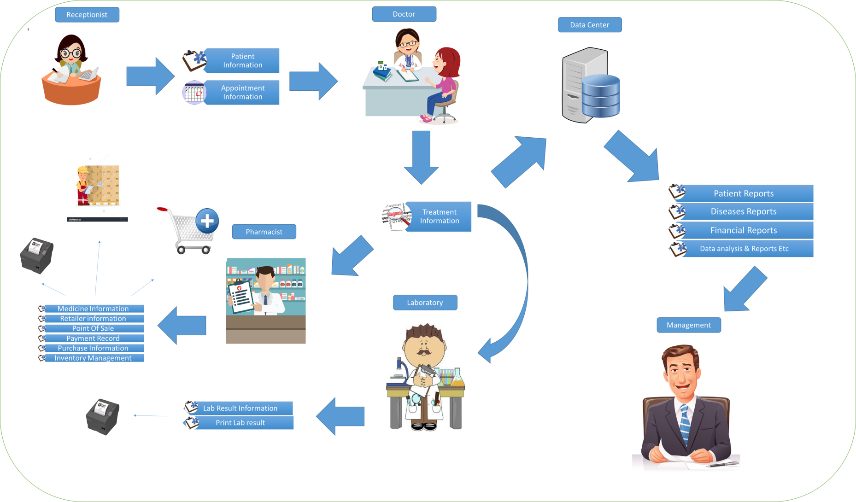

The new system in algorithms
Adding a record (patient):
enter details
validate the data
if valid then
save the data
print “New record was added successfully”
else
print “Invalid data, please check the details you entered then try again”
end if
Delete a record (patient):
enter data
open the file
search for the data
if the data was found then
delete data
print “Data Deleted, you can still view the deleted data in the ‘deleted data’ table”
else
print "Data not found"
end if

Updating a record (patient):
input data
open file data
search for the data
if found then
update the data
print “Data Updated”
else
print "Data Not Found"
end if
Searching for specific record (patient):
Enter patient ID
open the file
search for the data
if found then
display the data
else
print "Data not found"
end if

